Lesson 4
Relations, Functions and Graphs

sPECIFIC OBJECTIVES:
At the end of the lesson, the student is expected to be able to :
- distinguish functions and relations.
- identify domain and range of a function/relation.
- evaluate functions/relations.
- perform operation on functions/relations.
- graph functions/relations.

4.1 Relation

Definition 4.1.1 Relation

Relation is referred to as any set of ordered pair. Conventionally, it is represented by the ordered pair ( x , y ). x is called the first element or coordinate while y is the second element or coordinate of the ordered pair.

4.2 Ways of Expressing a Relation

There are five ways of expressing a relation, namely:

1) Set notation 3) Equation 5) Mapping
2) Tabular form 4) Graph

Example 4.2.1 Express the relation 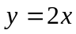; x = 0, 1, 2, 3 in 5 ways.

a. Set notation
(a) S = { ( 0, 0) , ( 1, 2 ) , ( 2, 4 ), ( 3, 6) }
(b) S = { (x , y) such that y = 2x, x = 0, 1, 2, 3 }

b. Tabular Form :

| x | 0 | 1 | 2 | 3 |
| y | 0 | 2 | 4 | 6 |

c. Equation: y = 2 x

d. Graph: e. Mapping:

X Y
0
1
2
3

0
2
4
6

4.3 Domain and Range

Definition 4.3.1 Domain and Range

All the possible values of x is called the domain and all the possible values of y is called the range. In a set of ordered pairs, the set of first elements and second elements of ordered pairs is the domain and range, respectively.

Example 43.1 Identify the domain and range of the following relations.

a) S = { ( 4, 7 ),( 5, 8 ),( 6, 9 ),( 7, 10 ),( 8, 11 ) } ans. D: { 4,5,6,7,8}
R:{7,8,9,10,11}

b) S = { ( x , y ) s. t. y = | x | ; x ∈ R } ans. D: all real nos.
R: all real nos. > 0

c) y = x ² – 5 ans. D: all real nos.
R: all real nos. > -5

d) | y | = x ans. D: all real nos. > 0
R: all real nos.

e) 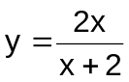 ans. D: all real nos. except -2
R: all real nos. except 2

f) 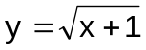 ans. D: all real nos. > –1
R: all real nos. > 0
g) 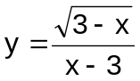 ans. D: all real nos. < 3
R: all real nos. except 0

Exercise 4.3.1 Identify the domain and range of the following of each of the

following relations.

- {(x,y) | y = x ² – 4 }
- 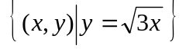
- 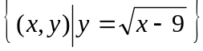
- 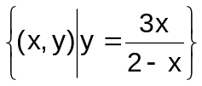
- 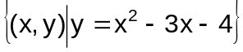
- y = | x – 7 |
7. y = 25 – x ²
8. y = (x ² – 3) ²
9. 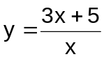
10. 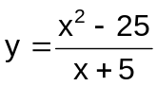

4.4 Function

Definition 4.4.1 Function

A function is a special relation such that every first element is paired to a unique second element. It is a set of ordered pairs with no two pairs having the same first element.

Example 4.4.1 Identify which of the following relations are functions.

a) S = { ( 4, 7 ), ( 5, 8 ), ( 6, 9 ), ( 7, 10 ), ( 8, 11 ) } ans. function
b) S = { ( x , y ) s. t. y = | x | ; x ∈ R } ans. function
c) y = x ² – 5 ans. function
d) | y | = x ans. not function
e) ans. function
f) ans. function

g) ans. function

Exercise 4.4.1 Identify which of the following relations are functions.

- {(x,y) | y = x ² – 4 }
- 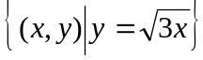
- 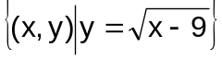
- y = | x – 7 |
7. y = 25 – x ²
8. y = (x ² – 3) ²
9.
10.

Defintion 4.4.2 Function Notations

Letters like f , g , h and the likes are used to designate functions. When we use f as a function, then for each x in the domain of f , f ( x ) denotes the image of x under f . The notation f ( x ) is read as “ f of x ”.

Example 4.4.2 If f ( x ) = x + 9 , what is the value of f ( x ² ) ?

ans. f ( x ²) = x ² + 9

Example 4.4.3 If g ( x ) = 2x – 12 , what is the value of g (– 2 )?

ans. g (– 2 ) = – 16

Example 4.4.4 If h ( x ) = x ² + 5 , find h ( x + 1 ).

ans. h ( x + 1 ) = x ² + 2x + 6

Example 4.4.5 If f(x) = x – 2 and g(x) = 2x² – 3 x – 5 , find

a) f(g(x)) b) g(f(x))

a) f(g(x))
f(g(x)) = (g(x)) – 2
f(g(x)) = 2x² – 3 x – 5 – 2
f(g(x)) = 2x² – 3 x – 7

b) g(f(x))
g(f(x)) = 2 [f(x)] ² – 3 f(x) – 5
g(f(x)) = 2 ( x – 2 ) ² – 3 (x – 2) – 5
g(f(x)) = 2 ( x² – 4x + 4 ) – 3x + 6 – 5
g(f(x)) = 2x² – 8x + 8 – 3x + 1
g(f(x)) = 2x² – 11x + 9

4.5 Operations on Functions

Definition 4.5.1 Operations on Functions

If f (x) and g (x) are two functions, then
a) ( f + g ) ( x ) = f(x) + g(x) ==> sum / difference
b) ( f g ) ( x ) = [ f(x) ] [ g(x) ] ==> product
c) ( f / g ) ( x ) = f(x) / g(x) ==> quotient
d) ( f g ) ( x ) = f (g(x)) ==> composite

Example 4.5.1 Given f(x) = 11– x and g(x) = x ² +2x –10 , evaluate each of

the following functions.

a) f(-5) ans. 16
b) g(-2) ans. -10
c) 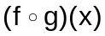 ans. –x ² -2x+21
d) 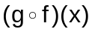 ans. .x² -24x+133
e) 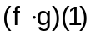 ans. -70
f) (f-g)(5) ans. -19
g) f(7)+g(x) ans. .x ² +2x –6
h) g(-1) – f(-4) ans. -26
i) 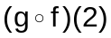 ans. 89
j) 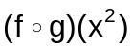 ans. –x ⁴ -2x² +21

Exercise 4.5.1 Given f (x) = 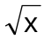 ; g (x) = 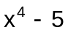 and h (x) = 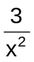, perform the

operations as indicated

1. g (– 5)
2. h (– 2)
3. ( g f ) ( x )
4. ( h f ) ( x )
5. ( g⋅h ) ( 1 )
6. (h – g) ( 5 )
7. f ( 7 ) + g ( x )
8. g ( – 1) – f ( 4 )
9. ( g ο f ) ( 2 )
10. ( f ο g ) ( x ² )

4.6 Graph of a Function

Definition 4.6.1 Graph of a function

If f(x) is a function, then its graph is the set of all points (x,y) in the two-dimensional plane for which (x,y) is an ordered pair in f(x).
One way to graph a function is by point plotting.

The following are the suggested steps to graph a function:
- Determine the dependent variable and solve the equation for it.
If y is a function of x, solve for y in terms of x.
- Determine any restrictions on the domain.
- Construct a table of values reflecting the domain restrictions, if they exist.
- Determine an appropriate scale for each axis.
- Plot the ordered pair and draw a line or a smooth curve through and
extending beyond the points.

Example 4.6.1 Graph the following functions.

- y = 3x – 5
- y = 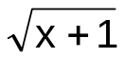
- y = 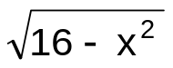
- f(x) = x ² – 5
- y = 2x ³

Exercise 4.6.1 Graph the following functions.

1. y = – x
2. f(x) = x ²
3. y = 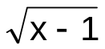
- y = 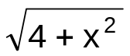
5. y = – ½ x ³

4.7 Polynomial Function

Definition 4.7.1 Polynomial function

If a function f is defined by
f (x) = a_{n} x ^{n} + a_{n-1} x ^{n-1} + a_{n-2} x ^{n-2} + ……+ a₁ x + a ₀
where a ₀, a₁….a_{n} are real numbers (a_{n} ≠ 0) and n is a nonnegative integer, then f is called a polynomial function of degree n.

A Linear function is a first degree polynomial function, the graph of which is a straight line
A Quadratic function is a second degree polynomial function, the graph of which is a conic section (circle, parabola, ellipse or hyperbola ).
A Cubic function is a third degree polynomial function, the graph of which is called a cubic curve.

Example 4.7.1 Graph each of the following functions.

a) y = 7 – ½ x
b) f(x) = 2 + x ²
c) y = 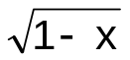
d) y = 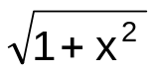
e) y = ( x +1) ³

Exercise 4.7.1 Graph the each of the following functions.

1. y = 7 – 2( x +1)
2. f(x) = 2 + (x – 1) ²
3. y = 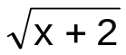
4. y = 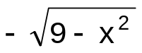
5. y = ( x – 2 ) ³

Definition 4.7.2 Absolute Value Function

An Absolute value function is a function that involves absolute value expression.

Example 4.7.2 Graph each of the following functions.

a) y = | x |
b) f(x) = | 2 + x |
c) y = | x | + 4
d) y = 3 – | 2x |
e) y = | 5 – x |

Exercise 4.7.2 Graph each of the following functions.

1. y = – | x |
2. f(x) = | 3 – x |
3. y = | x | – 7
4. y = x – | x |
5. y = | x | + x

Definition 4.7.3 Greatest Integer function

Greatest Integer function, denoted by 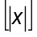, is the greatest integer less than or equal to x.

Example 4.7.3 Graph each of the following functions.

a) y =
b) f(x) = + 2
c) y = 4 –
d) y = – x

Exercise 4.7.3 Graph each of the following functions.

1. y = – 2
2. f(x) = – 3
3. y = x +
4. y = x –

Definition 4.7.4 One to one Function

A function f is aid to be one-to-one if and only if whenever a and b are any two distinct numbers in the domain of f, then f(a) ≠ f(b) .

Remark:

Vertical Line Test for Functions:

Draw a vertical line through the graph of a given relation. If this line intersects the graph at exactly one point, the relation is called a function; otherwise it is a relation.

Example 4.7.4 Identify which of the following is a one-to-one function:

a) c)

x ² +y ² = 4 x ² + y = 0

b) d)

y – x = 1 y ³ – x =1

e)

x ² – 4y ² – 4 = 0

Exercise 4.7.4 Graph the following and identify which is a one-to-one function.

1. | y | – x = 0

2. y ² + x = 4

3. x = 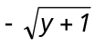

4. y + x ³ = 2

5. y + 3 ^{x} = 0

Definition 4.7.5 Inverse Function

If f is a one-to-one function determined by the set of ordered pairs (x,y), then there is a function f ^{–1} , called the inverse function of f, such that its set consists of the ordered pairs (y,x) defined by

x = f ^{–1} (y) if and only if y = f (x)

The domain of f ^{–1} is the range of f and the range of f ^{–1} is the domain of f.

Example 4.7.6 Find the inverse of the following functions and determine if the
inverse is also a function.

a) y = 2x + 5 ans. f ^{–1} (x) = ½ ( x –5 ); function

b) y = x ² – 1 ans. f ^{–1} (x) = 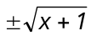; not function

c) f(x) = x ³ – 10 ans. f ^{–1} (x) = 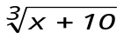; function

d) f(x) = x ² + 2x – 1 ans. f ^{–1} (x) = 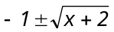 ; not function

e) y = 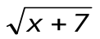 ans. f ^{–1} (x) = x ² – 7 ; function

Exercise 4.7.5 Find the inverse of the following functions and determine if the
inverse is also a function.

1. y = 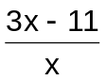

2. y = 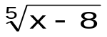

3. f(x) = (5 – x ) ³ + 2

4. f(x) = x ² + 2x – 1

- y = 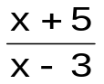

4.8 Transcendental Function

Definition 4.8.1 Transcendental Functions

Transcendental Functions are non-algebraic functions, which include:
- Exponential function

Logarithmic function
- Trigonometric function

Example 4.8.1 Graph each of the following functions.

a) y = sin x
b) f(x) = – 3 cos x
c) y = 2 ^{x}
d) y = e ^{x +1}
e) y = log₂ x

Exercise 4.8.1 Graph each of the following functions.

1. y = – sin x
2. f(x) = 5 + cos x
3. y = –3 ^{x}
4. y = e ^{x – 1}
5. y = log₄ x

